MLOps Inference Platform: Designing a Scalable Architecture

Table of Contents

1 General Architecture 3
2 Hardware Requirements 4
3 Used technologies 5
4 Components 8
5 Types of host filesystem access 9
Local volumes 9
Network storage 10
6 SFTP Server Setup 10
7 ML Ops implementations and K8s Manifests . 11
8 Monitoring & Logging (EFK & Prometheus) 13
9 Monitoring & Logging (EFK & Prometheus) 14

1 General Architecture

At its core, the environment is operated via AWS Container Engine (managed Kubernetes cluster). While there is a separation of hosts for applications connected directly to the public internet, e.g. ingress controllers and backend applications, a direct application-to-machine mapping is not possible due to the cluster-approach.
Applications in general will be referred to as “microservices” in this chapter, to reflect this. A microservice typically consists of an application that is packaged into a Docker container which can be configured via environment parameters, or retrieve configuration directly from Vault. In the cluster context, components that interact closely to provide a specific feature or functionality for the host model product are grouped into namespaces.
While most services within the cluster do not required direct internet access, it also consists of some services that integrate directly with external customer APIs and therefore require internet access. Due to security regulations, the access of resources on public internet is only possible indirectly via an internal forward proxy, where outgoing communication paths are required to be whitelisted.

The model host endpoints are publicly accessible via multiple domains/endpoints. This includes application, as well as monitoring and administration endpoints.

To nurture scalability central components of the application environment are only accessible over the internet via Elastic Loadbalancer. Within the cluster Kubernetes provides loadbalancing capabilities by using Service Discovery for communication between the components. Microservices are never exposed directly, but instead rely on Ingress Controllers to provide external access, which in turn usually are located behing ELBs. Combining those features provides an easy and effective way to scale the application.

Most components within the cluster can be setup fully automated, which enables the operation team to setup completely new environments quickly. Although not fully automated, the deployment process is constantly improved to reduce the manual efforts required for performing standard changes, e.g. updating components.

Although OS access is usually not required in this cluster architecture, as AWS or the on prem servers in general act as mere kubernetes-node that are fully managed via EKS, it is possible to access hosts directly. System accounts are managed by a central identity provider service and need to be accessed via AWS console. This level of access is limited to 2nd level support (operations team).
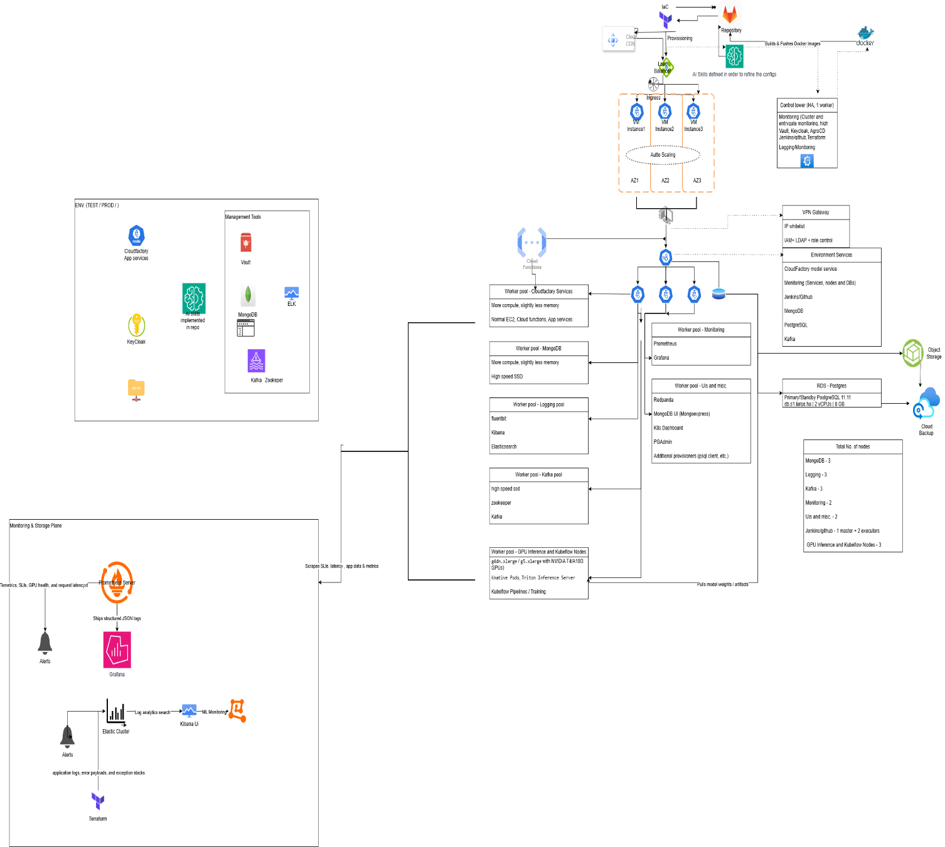
Diagram to the architecture- Link

2 Hardware Requirements
As infrastructure resources are constantly improved and updated in AWS Cloud, hardware resources are not strictly documented here. Instead, general concepts of every host model requirement are listed here:
- Compute Resources with a few exceptions are not managed directly, but indirectly as EKS Kubernetes Cluster nodes. The aim is to maintain mostly identical flavors as Node Pools with EKS, that can be scaled up or down, as required by the application. With this flavor sizes are unified and the environment is kept manageable. Another benefit of deploying the application only onto EC2 servers that are part of EKS node pools is, that instead of maintaining and regularly patching all servers individually, old nodes of a pool can be directly replaced with new (fully updated) nodes via built in K8S mechanisms, making long-lasting and error-prone OS patch installations obsolete.
- Whenever applicable and economically feasible, managed services are used in favor of self-hosted solutions for infrastructure elements, like Databases, or logging solutions. This only applies to managed services, where AWS is able to provide up-to-date solutions.
- Each environment has at least one EC2 with EIP attached that is designated as entrygate-server to the environment, in case direct access to the servers is required.

3 Used technologies
The following technical components are used to setup and operate the environment.
Software product | Purpose | Description
Docker | Application Deployment | All application components (microservices) are packaged into separate Docker containers. Configuration is possible via environment variables.
Kubernetes | Application Deployment/Operation | Manages all EC2 servers as Kubernetes nodes and deploys containers in environment.
AWS Deployment server | Application Deployment | AWS-managed private Docker registry. Host majority of container images that are deployed to the environment.
Jenkins | Application Deployment | Automation of release deployment, configuration updates, Kafka topic creation and endpoint exposure. Configuration is persisted via Jenkinsfile.
Gitlab | Configuration Storage | Environment specific configuration files for Jenkins and Docker images are persisted here. Contains also custom developed scripts, Prometheus Exporters and other ELK tools.
MySQL DB / Postgre SQL DB | Data persistency | Main relational SQL database in environment. Provided by AWS Relational Database Service.
Mongo DB | Data persistency | Main No-SQL database in environment. Older versions (3.4) are provided by AWS Database service, while newer versions (>4.0) are self-hosted.
ELK | Monitoring | Central logging is implemented via Elasticsearch, FluentD and Kibana setup.
Prometheus/Grafana | Monitoring | Prometheus tracks performance metrics from every EKS and container in the environment. Grafana is used to visualize collected data.
NGINx/Traefik | Environment access | Main ingress controllers. They function as reverse proxy and handle SSL termination for incoming requests.
Let's Encrypt | Environment access | In all environments Let's Encrypt is used to provided SSL encryption for all application product domains.

List of Platform Components (Different components which are deployed not as Application related Component
Component | Purpose | Description | Ops documentation | Helm Chart Version | Image Version
Keycloak | Single Sign On | Provide SSO for customers and Cloudfactory |  | keycloak-18.1.1
Jenkins or GitHub | CI/CD | Used for build and deployment |  | jenkins-2.56.3
Kafka |  |  |  | kafka-16.0.1 | docker.io/bitnami/kafka:3.1.0-debian-10-r0
Zookeeper |  |  |  | zookeeper-8.0.1 | docker.io/bitnami/zookeeper:3.7.0-debian-10-r265
Vault |  |  |  | vault-0.15.0 | hashicorp/vault:1.8.1
Redis |  |  |  | redis-17.1.4 | docker.io/bitnami/redis:6.2.6-debian-10-r120
MongoDB |  |  |  | mongodb-10.31.5 | docker.io/bitnami/mongodb:4.2
Prometheus |  |  |  | kube-prometheus-stack-34.9.0 | quay.io/prometheus/prometheus:v2.34.0
Grafana |  |  |  | kube-prometheus-stack-34.9.0 | grafana/grafana:8.1.2
Alert Manager |  |  |  | kube-prometheus-stack-34.9.0 | quay.io/prometheus/alertmanager:v0.24.0
Fluentbit |  |  |  | fluent-bit-0.19.22
Elasticsearch |  |  |  | elasticsearch-8.14.0
Kibana |  |  |  | kibana-7.14.0
Ingress (Nginx) Ngapp |  |  |  | ingress-nginx-4.0.18
Ingress (Nginx) Nginx |  |  |  | ingress-nginx-4.0.16
AWS Terraform provider | AWS resources | API call towards AWS | https://registry.terraform.io/providers/hashicorp/aws/latest/docs |  | To manage this AWS MLOps infrastructure cleanly and reproducibly, you can organize infrastructure code into modular Terraform modules. This approach separates concerns between networking, cluster orchestration, dynamic compute provisioning (Karpenter), and model artifact storage (S3).

4 Components
Components of the system:
Component | Kubernetes Namespace | AWS resource | Description
Ingress LB | Ingress LB #1 | EC2 | HTTP/HTTPS Reverse proxy for access to REST services of Host model app product
Ingress LB | Ingress LB #2 | EC2 | HTTP/HTTPS Reversy proxy for access to monitoring tools
Keycloak | Keycloak | EC2 | Keycloak identity and authentication management
Elasticsearch | ELK |  | Components to aggregate logfiles for all application parts and searching
Kibana | ELK | EC2
Prometheus | Prometheus | EC2 | Components for collecting system metrics and performing check for system monitoring
Grafana | Prometheus | EC2
GPU and Kubeflow | Kubeflow | EC2 | Use central Amazon S3 bucket and configure workflow default node selectors to target GPU worker pools during heavy training jobs.
MySQL/PostgreSQL DB |  | RDS | Central MySQL database for various components
Mongo DB |  | EC2 | Central Mongo database for various components
Kafka |  | EC2 | Central messaging bus
ObjectStore |  | S3 | Storage for CloudArchive

All components listed in the table are hosted on virtual resources in the AWS and on prem. The operating system for all EC2 is Linux.

5 Types of host filesystem access
Some pods will require access to a filesystem mounted to the host node to either read data from shared configuration files or to persist data.

Local volumes
Infrastructure services that require fast access to persisted storage, are hosted on servers with additionally attached local data disks. As an example this applies to log-storage for Kafka brokers, or index-storage for monitoring and logging services within Host model app.

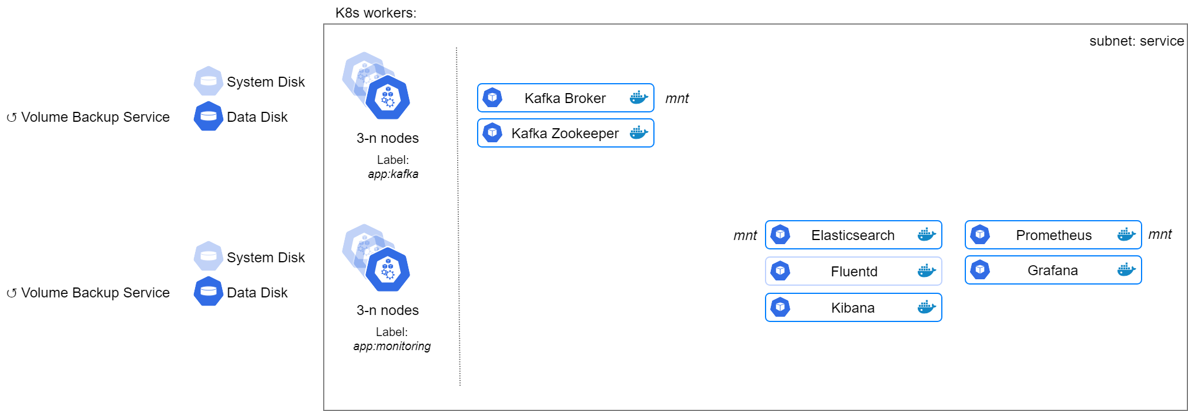

Network storage
While with EFS(Elastic file system) the AWS offers network storage that is scalable and can be attached to any POD directly, it comes with limitations: Slowness and missing backup mechanisms. Those two factors are a showstopper for using EFS to store any non-reproducible data.
Instead a NFS cluster is used to satisfy high-availablity requirements as well as to provide adequate read-/write-performance. In addition it is also possible to used standard AWS EVS backup mechanisms to backup any data store in the file-share.
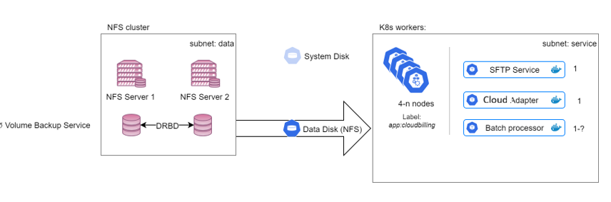

A single node setup without redundancy or replication is established to provide File-Shares to all Docker containers in the K8s network. The file-system is also backed up via AWS EBS.

6 SFTP Server Setup

The SFTP server is hosted directly on a dedicated EC2 server that resides in its own subnet and uses its own security group. Access to the EC2 is possible from the EIP, although SourceIPs allowed to access the server are maintained directly in the Security Group to limit the amount of potential origins. FTP users are chrooted and access to the filesystems is limited by POSIX ACLs.
The server is not connected to central IPA(Identity, Policy, and Audit) user management to mitigate the risk of gaining further access in case of a security incident. System logfiles are however transferred via syslog to a central log-server.

7 ML Ops implementations and K8s Manifests
This manifest defines a model deployment that scales based on concurrent requests, leveraging an S3-backed model URI and requesting GPU hardware acceleration.
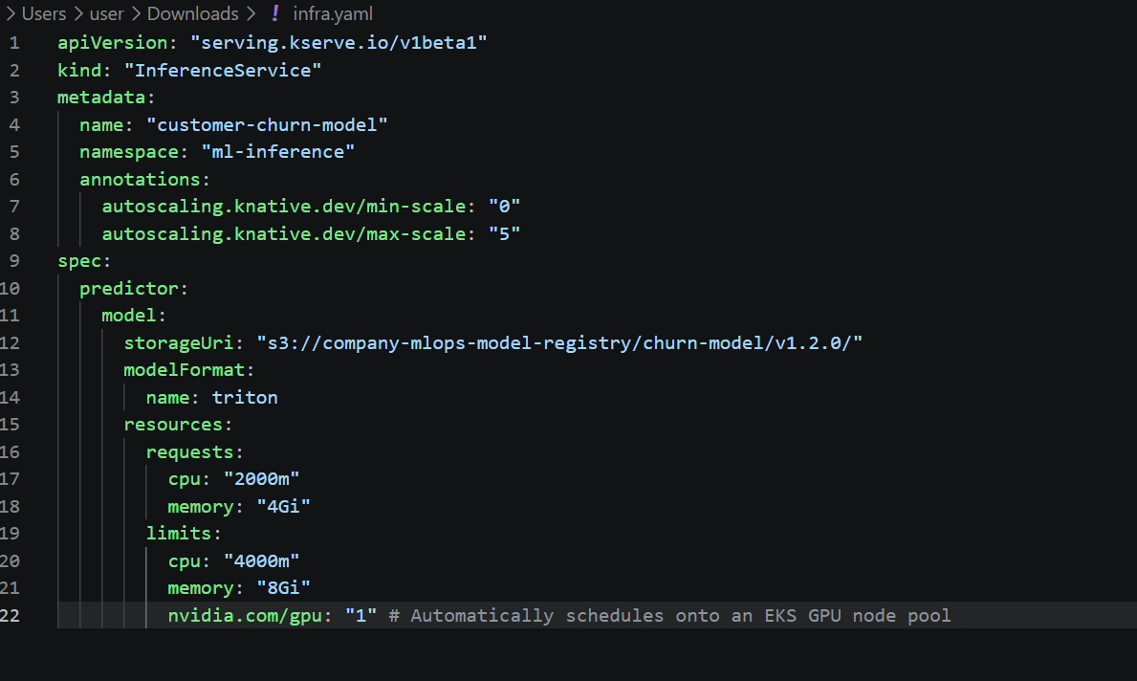
Building and deploying stage of the ML models using Github.
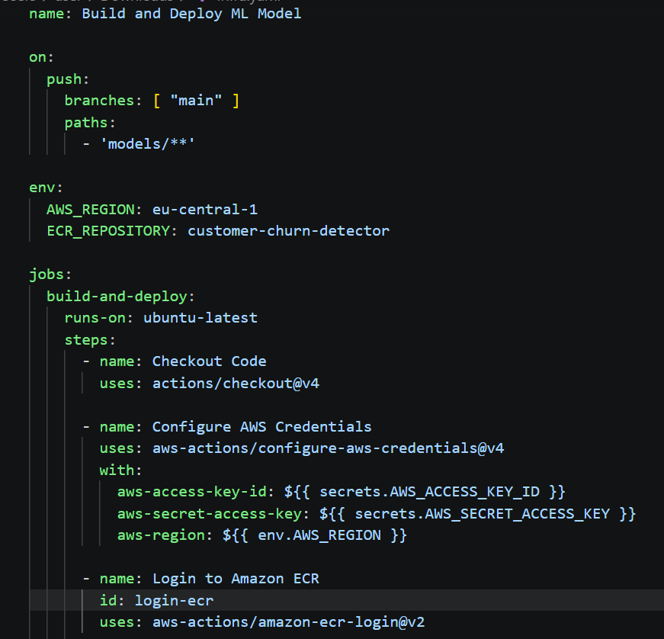
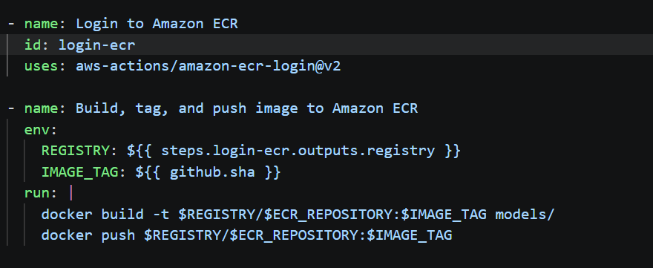

To provision GPU-accelerated nodes dynamically with Karpenter on AWS EKS, you need two custom resources: an EC2NodeClass (which handles AWS-specific configurations like subnets, security groups, and Amazon Machine Image selection) and a NodePool (which defines instance families, capacity types like Spot vs. On-Demand, and scaling rules).

8 Monitoring & Logging (EFK & Prometheus)
Machine learning models require a blend of traditional infrastructure monitoring and ML-specific observability (data drift, latency profiles) by implementing below.
Metrics & Telemetry: Prometheus and Grafana. Infrastructure Metrics: CPU, GPU utilization, memory footprint, pod restart loops, and queue depths.
Service-Level Objectives (SLOs): P99 inference latency, request error rates (HTTP 5x00 and model-specific prediction errors), and throughput (requests per second).
Tracing is critical for multi-model pipelines where a single user request might chain calls across several models.
Logging: Fluentbit or Vector shipping structured JSON container logs to a central backend (such as Grafana Loki or Kquery).
Using Kibana ML model inputs/outputs asynchronously, triggering alerts if feature distributions drift significantly from training baselines. With the ML models in Kibana the monitoring worker calculates drift and operational metrics, expose the results through a Prometheus scrape endpoint. Prometheus can scrape the monitoring worker's /metrics endpoint. Grafana can then visualize the time series and alert on sustained changes. By keeping metric labels bounded. Model name, version and a controlled feature identifier can be suitable, but avoid user IDs, request IDs, raw feature values or unbounded prediction text in labels.
To capture the metrics from the Kubernetes deployments for GPU and for the Kubeflow it can capture exact metrics using the field creation with using painless script. Implementation of fluentD and the Prometheus exporter with analyzing the cloudwatch and server logs makes much reliable when it comes to the alerts creation in ELK we can implement them using Terraform configurations in order to make them reusable.
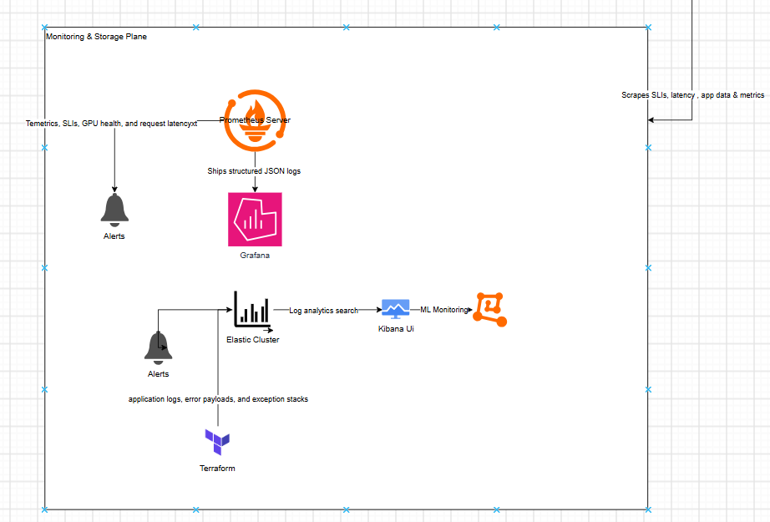

9 Monitoring & Logging (EFK & Prometheus)

Releasing and Updating Model VersionsModel Packaging & Registration: The ML team trains a model, packages it into a Docker image, and pushes it to AWS via automated Jenkins or Github pipelines.
GitOps Manifest Update: A configuration change in Git updates the model's deployment tag (e.g., upgrading from model version v1.1 to v1.2).
Canary Deployments & Traffic Splitting: Using weighted Ingress rules or traffic splits, the platform routes a small percentage of production traffic (e.g., 10%) to the new model version (v1.2) while keeping 90% on v1.1.
Automated Grafana/Prometheus alerts monitor error rates and latency on the new version. Automated Rollback: If error rates spike or latency exceeds thresholds on the canary version, traffic is automatically reverted 100% back to the stable version without manual intervention.
Obviously we can configure the default rollback strategy for the Kubernetes in this scenario as well.
As mentioned above with the SLA definitions we can suggest what availability and p99 latency target, and why? For defining the target levels and breaching factors.
Instead of alerting on single error spikes, use Multi-Window Multi-Burn-Rate Alerts to catch rapid error budget depletion without generating false positives. Create Prometheus recording rules to calculate error budget consumption. Configure Grafana Dashboards to visualize live SLI tracking against your SLO targets.

